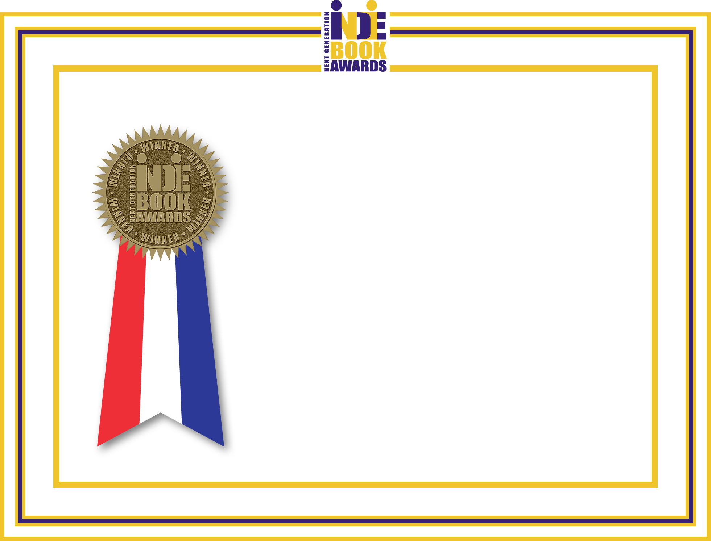

2013 Next Generation Indie Book Awards

WINNER

Parenting/Family

Awarded to
The Dad Checklist: Practical Skills to Teach Your Children

Presented by Independent Book Publishing Professionals Group May, 2013

